Safe Berks

Board of Directors Meeting Agenda

Date June 28, 2018 @ 8:00 AM

Location: Safe Berks Center, 255 Chestnut St., Reading

Conference Call Information: Dial in No. 1-877-860-3058
Guest Passcode 7148513#
______________________________________________________________________________

Executive Session – CEO Evaluation Data Review

- Call to Order - Vicki Ebner
- Consent Agenda
  - Approval of Minutes: May 24, 2018
  - Executive Committee Minutes – June 20, 2018
  - Finance Meeting Minutes – June 20, 2018
  - Employee Retention Committee Minutes – June 11, 2018
- Finance
  - Financial Statements – May 2018
- Employee Retention Committee
- Governance Committee
- Development Committee
- CEO Report
- President’s Report
- Old Business
- New Business
- Announcements
- Adjournment
Upcoming Meetings:
Finance Committee – August 15, 2018 8 AM
Executive Committee Meeting – August 15, 2018 9 AM
Next Board Meeting – August 23, 2018 at 8 AM

HAPPY SUMMER – STAY SAFE!!

Safe Berks

Board of Directors Meeting Minutes

Date May 24, 2018 @ 8:00 AM

Location: Safe Berks Center, 255 Chestnut St., Reading

Conference Call Information: Dial in No. 1-877-860-3058
Guest Passcode 7148513#

Attending: Karima Archie, Nina Bohn, Tina Boyd, Joe Cicala, Karen Cook, Carlixta De LaRosa, Diane Duff, Susan Fromm, Amanda Jackowski, Jay Mahoney, Tim Marks, Mary Ann Moffitt, Steve Ohnsman, Mark Wallace
Telephone: Vicki Ebner
Excused:
Absent: Michele McCartney
Staff:, Mary Kay Bernosky, Jasmine Suarez

Education: Stacey Jordan, newly hired Campus Advocate/Paralegal introduced herself, gave her background and spoke about the priorities she has regarding establishing a campus presence

Nina Bohn called the meeting to order at 8:06 AM.
Susan Fromm made a motion to approve the Consent Agenda; Amanda Jackowski seconded the motion. Motion Carried.
  - Approval of Minutes: April 26, 2018
  - Executive Committee Minutes – May 16, 22018
  - Finance Meeting Minutes – March 21, April 18 & May 16, 2018
  - Board Facilities Meeting – May 17, 2018
  - Employee Retention Meeting – May 14, 2018
Finance
Financial Statements – April 2018
- Unrestricted cash is low. There were 3 payrolls in March; quarterly reports are due in April to our major funders, but cash does not come in until May and we paid down the mortgage.
- Staff will notify the Finance committee is we use restricted money as a temporary loan to ourselves until grant money comes in.
- We should work to increase Peace Trust membership every year rather than every 5 years when the current pledge term ends. The money received in a pledge is booked in the year it was pledged; not in the year in which payments against that pledge are made.
Carlixta made the request that the slides that Jasmine presents at the board meeting be loaded onto the portal at the same time as the Monthly mailing.

Karen Cook made a motion to approve the financial statements as presented: Diane Duff seconded the motion. Motion carried.

Amanda reported that the fiscal procedures manual will be posted on the portal. This is basically a work flow plan for finance.

Governance Committee –Joe Cicala reported that response to the surveys has been good. The committee is on schedule for a July meeting with Mary Kay. Thanks to everyone for participating. There will be a committee meeting directly following this meeting.

Development– We have raised $22,000 so far for the Walk. Most of this money is from sponsors. We have already exceeded last year’s total of $19,000. The committee held a Team Captains meeting this week. They provided information on recruiting walkers, helping with fundraising and answering questions. The art teacher from Southwest Junior High was on hand to help the group make signs for the walk.

CEO Report – Mary Kay has been asked to speak again at the Moms Demand Action group. They are working to make some changes regarding the firearm confiscation when a PFA is involved. Currently a person has 60 days to turn all firearms over to someone (could be a relative). The group would like to see this changed to 48-hour time limit and that the firearms must be turned into law enforcement. The is a non-partisan group concerned with gun safety, not confiscation.

Mary Kay met with the new Executive Director of PCADV. She learned that there will be some changes implemented around our accounting process. It is complicated and will require major adjustments.

Mary Kay received a letter from RHA indicating that their board has approved the purchase of Emma Lazarus place with a settlement of June 29!!

Playground – It has been decided to use concrete as a base since that is the preferred material to use. Decking and Matting have been donated. Since we are in a flood plain zone we will need to get a variance from zoning. Tom McDevitt is very familiar with the process and the “players” and has volunteered to help us with this. The other decision is whether the playground equipment should be in ground or on top of the surface. Jay Mahoney will check liability regarding this. Having the equipment in ground would require it to be dug up if we decide to change/replace equipment in the future. We are hoping to have the playground totally complete by end of summer.

We received $11,000 from RACC as proceeds from their RACCy Olympics. Funds are designated for the playground.

Old Business – None

New Business – Tim Marks has agreed to chair a resurrected Medical Advocacy group. He and Mary Kay will work over the summer to kick off the new committee in the Fall. The main purpose of the group will be education. They will also train residents how to access health care and train health care professionals to screen for domestic violence. Penn State Health St. Joseph, Tower Health and Community Health care will all be involved. We hope to involve potential new board member Eve Kimball in this group.

Vicki wanted to ensure that new board members realize that there is a voting process for bringing new board members on. We will vote in August on a slate. We will also vote to re-elect board members for a second term.

Susan Fromm made a motion to adjourn the meeting. Carlixta de la Rosa seconded it. The meeting was adjourned at 9:13 a.m.

Upcoming Meetings:
Finance Committee – June 20, 2018 8 AM
Executive Committee Meeting – June 20, 2018 9 AM
Next Board Meeting – June 26, 2018 at 8 AM

Respectfully submitted,

Jan Cremer
Executive Assistant/HR Coordinator

CEO Report to the Board
May 24, 2018

Our Walk for No More was a great success. We have raised about $33,000 and will keep our peer to peer fundraising open until 7/6. We will do a wrap up about the Walk in August.

Elizabeth Garrigan, our new COO will start on 7/9. Stephanie Moratoya, our new Counseling Director will start on 7/2.** The SART Coordinator Position has been approved in the VOCA grant and is posted. I will be working with COCA to develop an RFP for licensed substance abuse services for clients.

We will not be meeting as Committees or Board in July. I do expect an on-time State Budget so we will be able to review a draft of next year’s budget in August. As you know, August will be the first longer meeting so please anticipate 2 hours. We will also discuss our Board candidates.

Staff are working on performance reviews and determining how to manage merit based increases. We do expect additional VOCA money in the next year and we have some ideas but will wait to see what, if any, changes are made to approved expenses for VOCA.

Due to medical complications, Sharon Mast is unable to facilitate our 5 Dysfuctions Training. After looking for alternate facilitators, I will reach out to Joni Naugle to schedule the training in September.

Our staff retreat is Wednesday June 27th at the Fish Pond. Volunteers, (Missy and Diane Cappa) will be working that day so all staff may attend and enjoy some down time. We will have massages, exercise classes, tarot card readings, etc plus the ability to walk on the trails.

Thank you for all you did to support our Walk. I think we received good press and touched a lot of people during the day.

** After this report was submitted it was learned that Stephanie has decided not to accept the Safe Berks Director of Counseling position.

Safe Berks Board of Director’s Report – May 2018
Education and Outreach Department
Jennifer Ebersole, Director

Education, Awareness, Presentations, Trainings:
Schools: Governor Mifflin Middle School – Shifting Boundaries (primary prevention programming sessions completed); Berks Career and Technology Center, West – Healthy Relationships to early childhood and cosmetology classes.

Community Outreach: The following outreach meetings occurred: Executive Committee of the NAACP, Reading Branch; Berks Inter-Cultural Alliance (Karima Archie); Co-County Wellness Youth Ambassador Program. Tabling at First Responder Festival in Leesport.

Staff Development/Prevention Education Trainings - All Education and Outreach staff attended the following trainings and/or staff development: Camp Safe Berks facilitator training with Paul Kivel, author of curriculum Camp Safe Berks is based on; PCADV/PCAR Prevention Bootcamp at Safe Berks; PCADV statewide prevention summit. Two community educators attended PCAR “Parents in the Know” Train-the-Trainer

Presentations: Safe Berks was one of six centers chosen by PCADV to present the successes (and opportunities for improvement) of our Shifting Boundaries primary prevention curriculum to representatives of the Centers for Disease Control and Prevention and Pennsylvania Department of Health. We also conducted a DV 101 presentation to the Women of the Evangelical Lutheran Church of America, Northeast PA Chapter.

Media/Communications: People Chronicles podcast top promote Camp Safe Berks; BCTC appearance on Diversity: the Wider Vision programming with Dr. Amprey and panelists to promote Camp Safe Berks.

Camp Safe Berks:
Planning continues for Camp Safe Berks, which is scheduled for July 23-27, 2018 at Albright College. Staff is focused on promoting Camp to recruit campers and volunteers, sponsors and donors, and fine-tuning the activities and curriculum to be offered during each day. A SPECIAL THANK YOU to Safe Berks Board members - Steve Ohnsman and Karima Archie - for your commitment to help facilitate discussion and activities throughout the week. There remain several areas of need where we would be very grateful for the Board’s assistance in any capacity:
- Camp Outreach – sharing promotional flyer and recruiting campers (deadline is July 6, 2018.
- Large and small group facilitators to assist in leading discussions (one day, several days or all week)
- General volunteers throughout the day to assist with Camp logistics (one day, several days or all week)
- Camper Sponsorship - $300 for full sponsorship, or any amount to help defray costs.
- Snack donations –pre-packaged, store-bought and nut-free items that include consideration of camper dietary preferences such as gluten-free, vegan, kosher, etc. Grocery store gift certificates are encouraged for staff to purchase snack items.

Legal Department Director’s Report
Diane Ellis, Director of Legal Services
June, 2018

May, 2018 Legal Department Statistics

Total number of clients served by legal advocates and paralegal – 101
Figure includes 24 legal system accompaniments w/clients

Total number of clients receiving services from attorneys – 101
Figure includes 82 clients represented in PFA and SVPO actions

May, 2018 LAP Statistics

Total lethality screens performed by Police*: 18
Number of screens indicating high danger of lethality: 12
Number of individuals who did not participate in screening: 1
Number of individuals who agreed to speak to hotline:7
Number of individuals who accessed additional Agency services: 0

*12 screens performed by Reading PD; 4 by West Reading PD; 2 by Amity Twp PD;

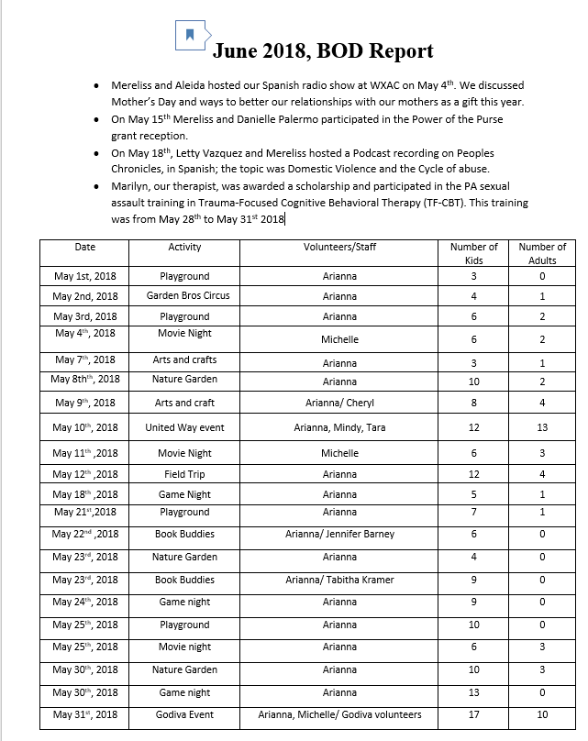

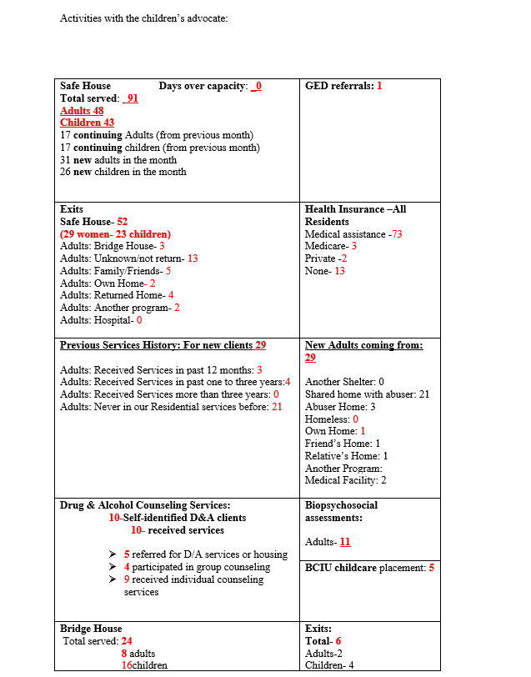
Executive Committee Minutes

A meeting of the Executive Committee occurred on Wednesday June 20, 2018 at Safe Berks. Present were Amanda Jackowski, Vicki Ebner and Mary Ann Moffit. Diane Duff participated by phone and Nina Bohn was excused.
Mary Kay updated the committee on recent staff changes and confirmed the new Counseling Director will start on 7/2. The SART job posting is out and Mary Kay is working with COCA to develop an RFP for licensed substance abuse services for clients.
The Walk for No More was a great success. We raised about $33,000 so far and are keeping the peer to peer fundraising open until 7/6. We will do a formal wrap up at the August Board meeting.
Due to the medical emergency with Sharon Mast’s husband our 5 Dysfunctions has been cancelled. I will follow up with Joni Naugle about scheduling in the fall.
Carolyn Holleran is encouraging Safe Berks to do a Capital Campaign to retire the Mortgage. Mary Kay will provide more information at the Board Meeting.

The meeting adjourned at 9:15 am.

Employee Retention Meeting
June 11, 2018

Attending:
Mary Kay Bernosky Danielle Reardon Jasmine Suarez
Jan Cremer Vicki Ebner Nina Bohn

Jasmine provided updated charts on new hires/terminations. We have had 1 new hire during the month – Vanessa Salazar who is 3rd shift 40 hours every other week. Tara Anspach and Daphne Ovalles officially terminated in May. For the year we have hired 11 people; 12 have left.
Staffing at the Safe House is going well. It appears as though we now have a strong team of staff and management. As time goes on we are finding that the Counseling Department was in worse shape than we thought. Supervision needs to be stressed very strongly when the new director begins. It may even be necessary to have oversight within the counseling session itself.
Staff reviews are due in June and will need to be distributed to staff with enough time for them to be completed. (2 weeks). This year there will be no wage adjustments or bonus money, so raises will be strictly based on performance evaluation. Raises are usually paid in October after the board approves the budget and are retroactive to July 1.
Intranet (The Safety Net) has only been operational a week, but usage is gradually increasing. It will take some time to get all staff accustomed to checking it daily. Jasmine ran a contest last week in an effort to check usage. Mary Kay indicated that we can use the Safety Net to announce that the conference room (#3) is available for use during lunch from 12 -1.
There has been no progress yet on the Social Committee bylaws.
Christine Gilfillan was the only exit interview that Danielle had this month. She had some comments about the structure of the COO position which Danielle will review with Mary Kay.
Jan was asked to produce a one sheet calendar of upcoming board meetings and topics to be discussed at each.
The meeting adjourned at 1:55pm.
Respectfully submitted,
Jan Cremer
Executive Assistant/HR Coordinator

Safe Berks Finance Committee
Minutes
6-20-18
Present: Vicki Ebner, Amanda Jackowski, Jay Mahoney, Diane Duff , Mary Ann Moffit
Absent: Marjorie Aherns, Doug Rauch,, Steve Pottieger, Carlixta De La Rosa, Nina Bohn
Staff Present: Mary Kay Bernosky (CEO), Jasmine Suarez (CFO), James Keaton (Staff Accountant).
Meeting called to order at approximately 8:00 A.M. by Amanda Jackowski
Finance Report:
- Presented by Jasmine Suarez, discussed by the Committee members included the Consolidated Statement of Financial Position at May 31, 2018 Consolidated Statement of Activities and Statement of Cash Flows for the month ended May 31, 2018, Consolidated Statement of Activities for the month ended May 31, 2018 and Financial Reporting – Items to Note.
  - Year to Date, Monthly Loss, the monthly loss was about 31K. while the Year to Date loss is currently at 48K. The Year to Date loss is better than the budgeted loss by about 79K for the year
  - Special Events is over budget for the year because of unusual/new donation events either by us or on our behalf. For example, the fundraising proceeds raised at the church concert, RACCy Olympics, gift wrapping (we are booked for next year already)
  - Competitive VOCA grant. We were awarded the Competitive VOCA grant we applied for last year. We have already started the search for SART Coordinator which will be funded by the grant, applications have already begun to come in. The grant will also help fund some of pay changes we made last year, and a partnership with an organization for outpatient drug/alcohol treatment. Mary Kay is working with Pat Giles to create an RFP.
  - State Budget. The state budget appears to be on course to pass on time this year. Meaning we will have our funding for the summer.

